Lesson 10 – Translating Flowcharts to Pseudocode – Example Problems
Convert the following flowcharts into pseudocode:
- Going to the café.
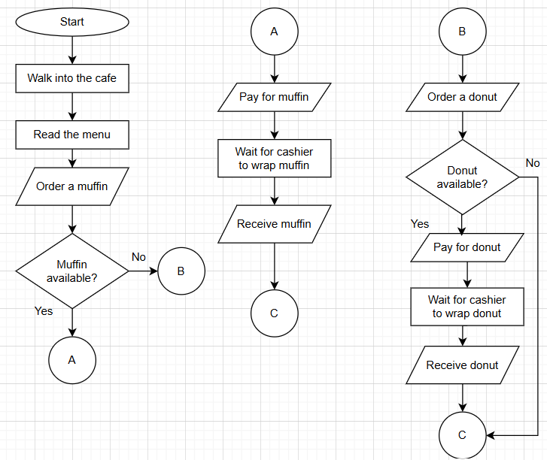
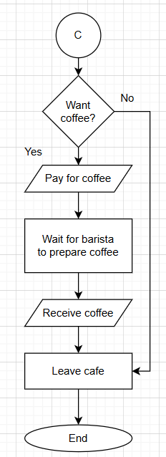
- Check if number can be easily divided into another.
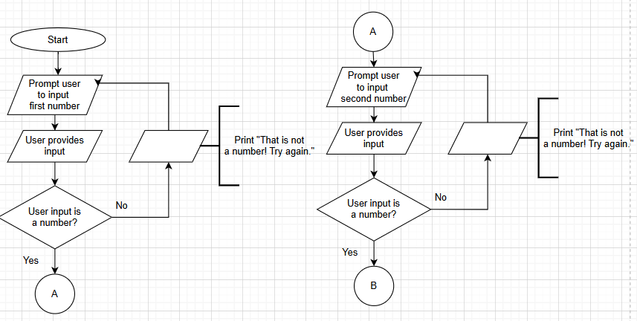
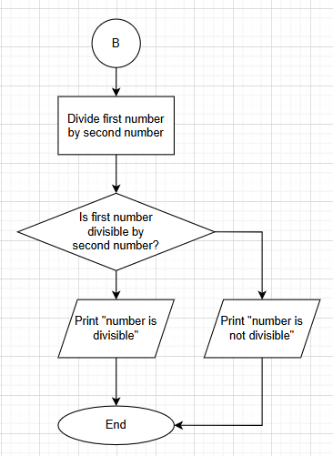
- Unsubscribe from streaming service.
